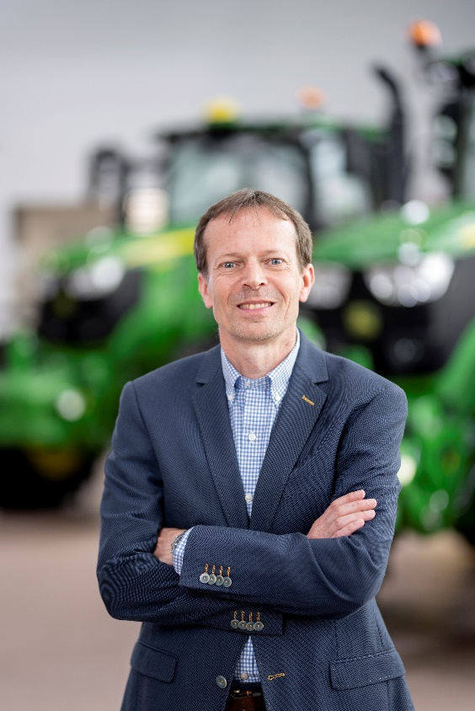
Jørgen Audenaert
Dear students, researchers, and Heeren XVII members,
It is great to be back in Wageningen. I graduated in 1990 as an Agricultural Engineer, with a strong interest in agricultural machinery and Precision Farming. My first thesis focused on a test method for fertilizer properties and distribution, and my second on simulation software for tractor-implement communication. During my internship at New Holland, I developed a combine setup-assistance tool and supported combine field testing in Spain.
After graduation, I joined Dutch sprayer manufacturer Douven in 1991 as a product engineer and became Product Manager in 1992. This role allowed me to gain broad experience from customers, dealers, and value-chain players in different markets. Working in a medium-sized company taught me how to respond quickly to emerging customer needs and deliver agile innovation.
In 1997, Deere acquired Douven, providing access to advanced technology and a global distribution channel. From 1998 to 2007, I lead product management, marketing, and customer support. During this period, we developed a completely new sprayer portfolio and integrated the first Precision Ag technology.
In 2008, I moved to our European Office in Mannheim as customer segment manager for contractors. This role expanded my horizon with the focus to strengthen our portfolio, marketing plans and services to grow business with contractors. Two years later, I also took on responsibility for large arable farmers in Europe and CIS markets. I was team lead to analyze future market needs and define product innovation opportunities for tractors, combines, forage harvesters, crop care and Precision Ag solutions.
From 2017, I became strategic marketing lead for Europe, covering all major segments and products. In 2018, I received the John Deere Fellow Award as an EU Precision Farming expert, the highest recognition at Deere for contributing to company success through expertise and leadership.
In 2020, Deere introduced the Smart Industrial strategy, and I became Manager Small Grains Production System Innovation. Since 2024, my role has expanded to include Dairy & Livestock.
Wageningen is also where I met my wife. Together, we have an 18-year-old son who will start his Agrotechnology Bachelor study at WUR in September.

Question: What are the three biggest challenges facing the European agricultural sector?

- Produce more & healthier food for a growing world population with less inputs (fertilizer, crop protection, water) while taking care of soil health and the environment

- Maintaining positive farm income in more difficult conditions with volatile commodity markets, higher geopolitical instability, dealing with climate change while farming within world’ most stringent environmental regulations and reduced CAP budgets

- Grow farm productivity with less skilled labor, tighter operating windows and more complexity to manage (Automation to Autonomy, Insights to Intelligence)

Statement: In 10 years, the first autonomous farm will exist.
We will definitely see a continuous growth of more automation of machines and implements and the use of more data- & knowledge based decision making (AI) in all production systems and steps from tillage to harvest.
Although John Deere has announced to deliver by 2030 the first autonomous corn and soybean production system in the US with autonomous tillage, planting, spraying and harvesting solutions, this does not mean that the farm will be fully autonomous.
Road transport and logistics of inputs and harvested crops from the field to the farm and storage of crops in a barn will still require human supervision or intervention.

